**DEPARTMENT OF INFORMATION TECHNOLOGY**

|  |
| --- |
| NAME: Ayush Vinod Upadhyay  ROLL NO: I025  SAP ID: 60003220131  BRANCH: Information Technology  BATCH: 1 |

# EXPERIMENT NO. 6

**CO/LO:** Develop web applications.

**AIM / OBJECTIVE:** Event Handling using Java Script

**THEORY:**

The change in the state of an object is known as an Event. In html, there are various events which represents that some activity is performed by the user or by the browser. When [javascript](https://www.javatpoint.com/javascript-tutorial) code is included in [HTML,](https://www.javatpoint.com/html-tutorial) js react over these events and allow the execution. This process of reacting over the events is called Event Handling. Thus, js handles the HTML events via Event Handlers.

For example, when a user clicks over the browser, add js code, which will execute the task to be performed on the event.

Some of the HTML events and their event handlers are:

**Mouse events:**

|  |  |  |
| --- | --- | --- |
| Event Performed | Event Handler | Description |
| click | onclick | When mouse click on an element |
| mouseover | onmouseover | When the cursor of the mouse comes over the element |
| mouseout | onmouseout | When the cursor of the mouse leaves an element |
| mousedown | onmousedown | When the mouse button is pressed over the element |
| mouseup | onmouseup | When the mouse button is released over the element |
| mousemove | onmousemove | When the mouse movement takes place. |

**Keyboard events:**

|  |  |  |
| --- | --- | --- |
| Event Performed | Event Handler | Description |
| Keydown & Keyup | onkeydown & onkeyup | When the user press and then release the key |

**Form events:**

|  |  |  |
| --- | --- | --- |
| Event Performed | Event Handler | Description |
| focus | onfocus | When the user focuses on an element |
| submit | onsubmit | When the user submits the form |
| blur | onblur | When the focus is away from a form element |
| change | onchange | When the user modifies or changes the value of a form element |

**Window/Document events**

|  |  |  |
| --- | --- | --- |
| Event Performed | Event Handler | Description |
| load | onload | When the browser finishes the loading of the page |
| unload | onunload | When the visitor leaves the current webpage, the browser unloads it |
| resize | onresize | When the visitor resizes the window of the browser |

**Code:**

1. Write a JavaScript function that changes the background color of an element when a mouse enters it.

1. Write a JavaScript program that adds a keydown event listener to a text input to detect when the "Enter key" is pressed.

<!DOCTYPE html>

<html lang="en">

<head>

  <meta charset="UTF-8">

  <meta name="viewport" content="width=device-width, initial-scale=1.0">

  <style>

    body {

      font-family: Arial, sans-serif;

      display: flex;

      justify-content: center;

      align-items: center;

      height: 100vh;

      margin: 0;

      background-color: #f0f0f0;

    }

    #square {

      width: 150px;

      height: 150px;

      background-color: blue;

      display: flex;

      justify-content: center;

      align-items: center;

      color: white;

      cursor: pointer;

      transition: background-color 0.3s, transform 0.3s, width 0.3s, height 0.3s;

    }

  </style>

  <title>Interactive Square</title>

</head>

<body>

  <div id="square"

       onmouseover="changeContinuousColors()"

       onmouseout="stopContinuousColors()"

       onclick="toggleShape()"

       onmouseenter="expand()"

       onmouseleave="shrink()">

       Hover over me

  </div>

  <script>

    var isCircle = false;

    var continuousColorChangeInterval;

    function changeColor(color) {

      var square = document.getElementById('square');

      square.style.backgroundColor = color;

    }

    function changeContinuousColors() {

      continuousColorChangeInterval = setInterval(function() {

        var randomColor = getRandomColor();

        changeColor(randomColor);

      }, 300);

    }

    function stopContinuousColors() {

      clearInterval(continuousColorChangeInterval);

    }

    function toggleShape() {

      var square = document.getElementById('square');

      isCircle = !isCircle;

      if (isCircle) {

        square.style.borderRadius = '50%';

      } else {

        square.style.borderRadius = '0';

      }

    }

    function expand() {

      var square = document.getElementById('square');

      square.style.width = '200px';

      square.style.height = '200px';

    }

    function shrink() {

      var square = document.getElementById('square');

      square.style.width = '150px';

      square.style.height = '150px';

    }

    function getRandomColor() {

      var letters = '0123456789ABCDEF';

      var color = '#';

      for (var i = 0; i < 6; i++) {

        color += letters[Math.floor(Math.random() * 16)];

      }

      return color;

    }

  </script>

</body>

</html>

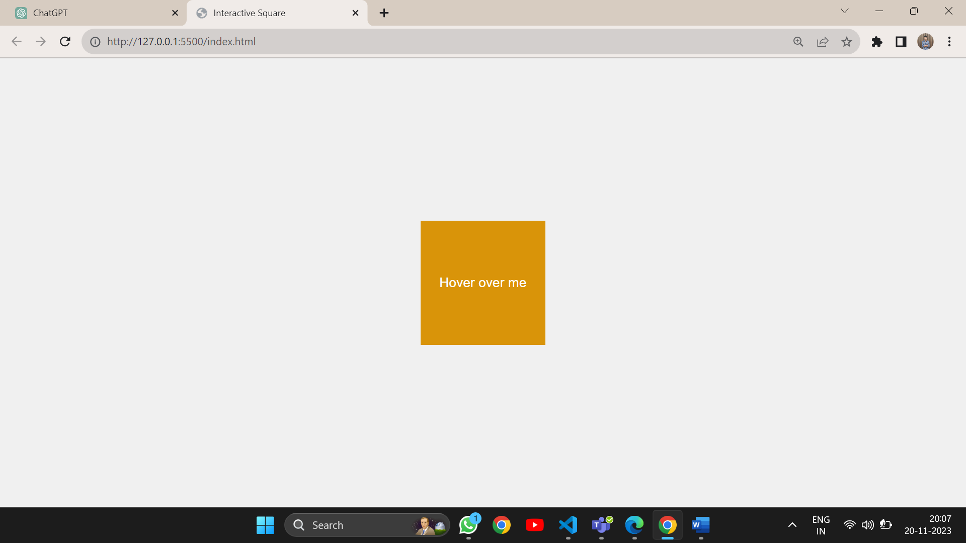 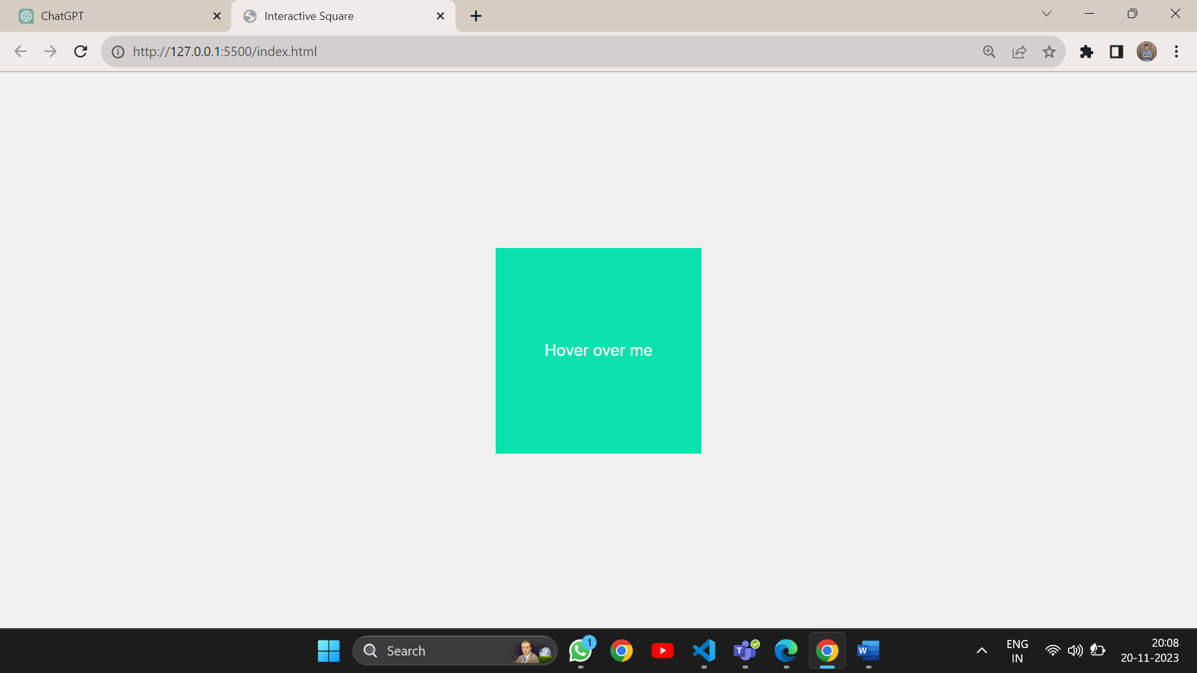 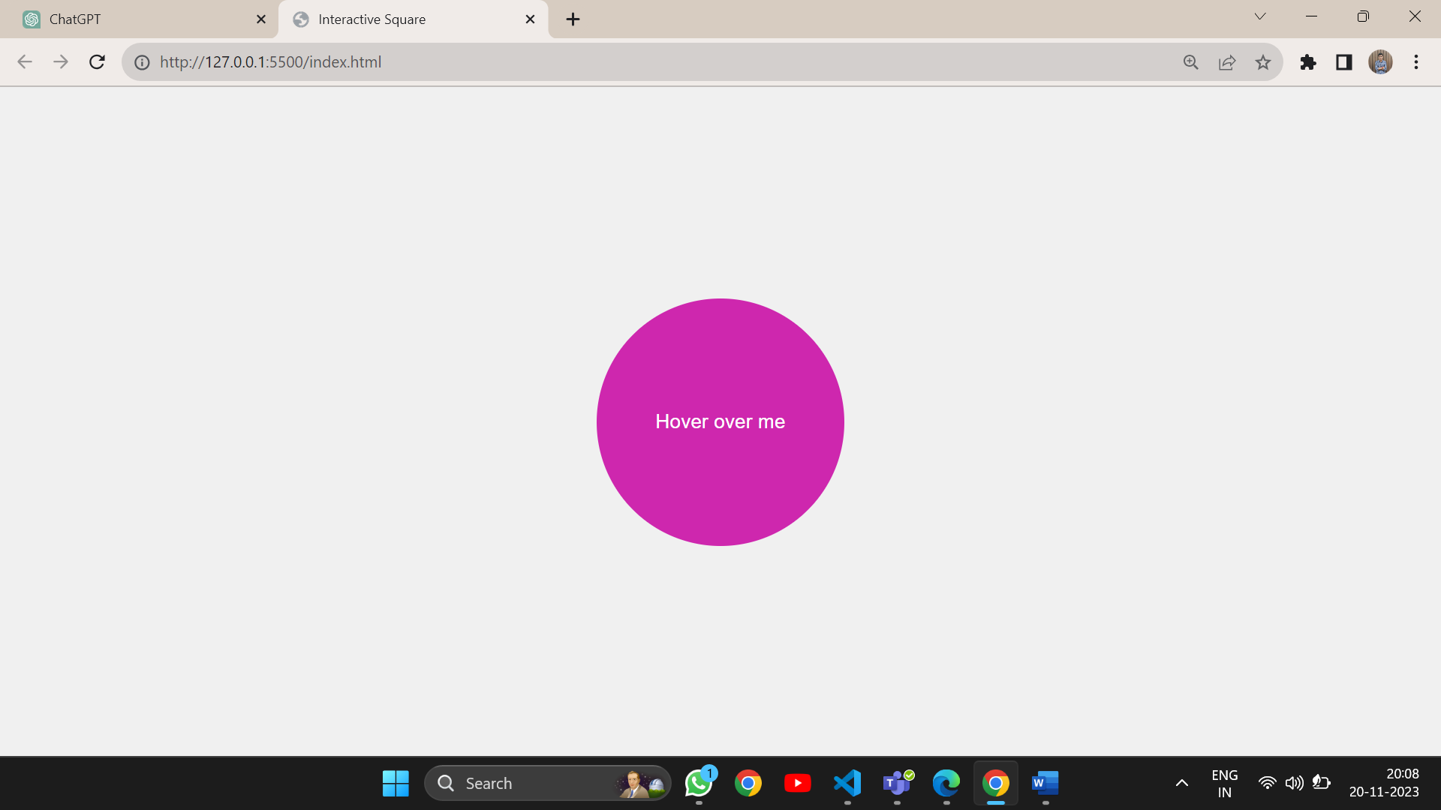

1. Write a code to display the input from user in the registration form onsubmit.

<!DOCTYPE html>

<html lang="en">

<head>

  <meta charset="UTF-8">

  <meta name="viewport" content="width=device-width, initial-scale=1.0">

  <style>

    body {

      font-family: Arial, sans-serif;

      display: flex;

      justify-content: center;

      align-items: center;

      height: 100vh;

      margin: 0;

      background-color: #f0f0f0;

    }

    form {

      text-align: center;

      max-width: 400px;

      margin: 20px;

      padding: 20px;

      background-color: #fff;

      border-radius: 8px;

      box-shadow: 0 0 10px rgba(0, 0, 0, 0.1);

    }

    label {

      display: block;

      margin-bottom: 8px;

    }

    input, select {

      width: 100%;

      padding: 8px;

      margin-bottom: 16px;

      box-sizing: border-box;

    }

    button {

      background-color: #3498db;

      color: #fff;

      padding: 10px 20px;

      border: none;

      border-radius: 4px;

      cursor: pointer;

      transition: background-color 0.3s;

    }

    button:hover {

      background-color: #2980b9;

    }

    #output {

      color: green;

      font-weight: bold;

    }

  </style>

  <title>Styled Form with Events</title>

</head>

<body>

  <form id="myForm">

    <label for="name">Name:</label>

    <input type="text" id="name" name="name" required>

    <label for="email">Email:</label>

    <input type="email" id="email" name="email" required>

    <label for="gender">Gender:</label>

    <select id="gender" name="gender" required>

      <option value="">Select</option>

      <option value="male">Male</option>

      <option value="female">Female</option>

    </select>

    <button type="submit">Submit</button>

  </form>

  <script>

    var form = document.getElementById('myForm');

    form.addEventListener('submit', function(event) {

      event.preventDefault();

      var name = document.getElementById('name').value;

      var email = document.getElementById('email').value;

      var gender = document.getElementById('gender').value;

      alert('Submitted Data:\nName: ' + name + '\nEmail: ' + email + '\nGender: ' + gender);

    });

    form.addEventListener('focus', function(event) {

      if (event.target.tagName === 'INPUT' || event.target.tagName === 'SELECT') {

        event.target.style.border = '2px solid #3498db';

      }

    }, true);

    form.addEventListener('blur', function(event) {

      if (event.target.tagName === 'INPUT' || event.target.tagName === 'SELECT') {

        event.target.style.border = '';

      }

    }, true);

  </script>

</body>

</html>

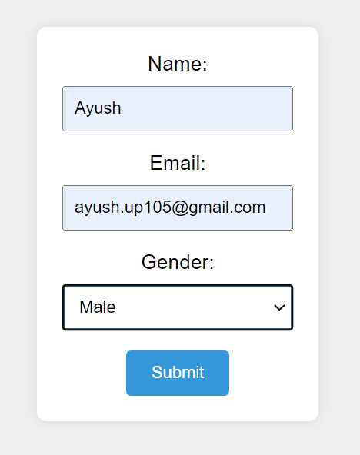

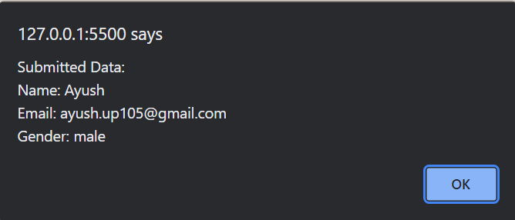

**BOOKS AND WEB RESOURCES:**

1. Tailwind CSS From Scratch | Learn By Building Projects by Brad Traversy
2. Tailwind CSS: A Modern Way To Build Websites Using CSS